Gas sensor

We are going to study the concentration of the following gases:

* **Liquefied petroleum gases** or **liquid petroleum gases** (**LPGs**), also referred to as simply propane or butane. They are flammable mixtures.
* H2
* **C0**

The sensor can measure signals from 300 to 10 000 ppm (10 000 ppm = 1 %)

In our application, the concentration values of the measured gases are needed, hence we need to scale the read values. However, the relation between the analogue reading and the real value is not linear and we need to estimate the curve that gives us the datasheet:

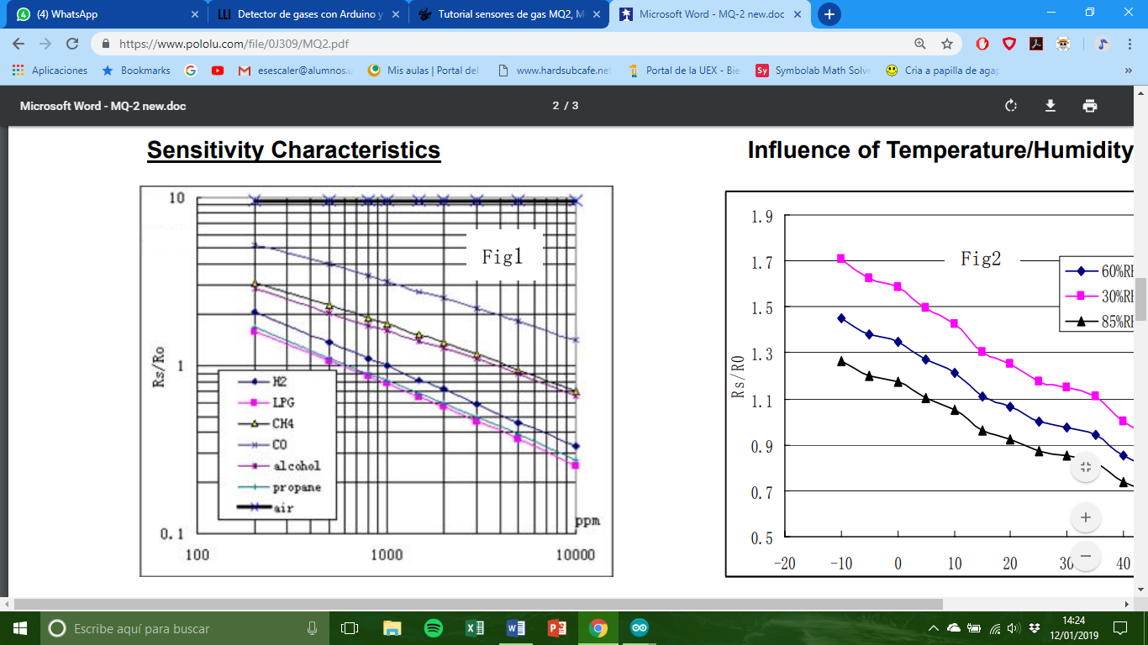

Since it gives us the curve and not the equation, it is necessary to estimate and make a regression to find the relation equation. In our case we will use Excel. For example, for the LPGs the graph is:

We obtain the formula:

$$\left[LPG\right]=482,67{\left(\frac{R_{s}}{R_{0}}\right)}^{-2,542}\text{,}$$

where $\left[LPG\right]$ is the concentration value of LPG, $R_{0}$ is a constant that equals the resistance of sensor in 1000 ppm Hydrogen and Rs is the resistance of the sensor, which we read from Arduino.

To calculate the value of $R_{s}$, we clear the equation of the voltage divider that forms the sensor with the load resistance $R_{L}$, that in most modules Is 1k.

$$V_{\text{read}}=5\frac{1000}{R_{s}+1000}$$

$$R_{s}=1000\frac{5-V_{\text{read}}}{V_{\text{read}}}$$

The $R_{0}$ reference value is calculated using the “mq2_r0” code. We should measure $R_{s}$ in clean air, but $R_{0}$ must be measured in H2. In clean air we obtained $R_{0}=2.70$ but the real value is usually much higher.

We repeat the process with the other gases:

Obtaining the corresponding concentration formulae.

$$\left[H_{2}\right]=871,81{\left(\frac{R_{s}}{R_{0}}\right)}^{-2,175}$$

$$\left[CO\right]=17250{\left(\frac{R_{s}}{R_{0}}\right)}^{-2,668}$$